Cockfield Primary School Uniform

Cockfield Primary School uniform helps to distinguish our pupils from others in the area. Wearing uniform gives children a sense of pride and belonging which enables ALL children to feel part of our school family. As a school, we believe that uniform is the practical and less expensive alternative to fashion clothing/shoes and as such will, in the long term, save our parents/carers money. All items should be labelled with your child’s name. Our school would discourage the purchase of expensive items such as coats and jackets as the school cannot be held responsible if items go missing.
From September 2021 we are introducing an ‘active’ school uniform. Wearing an active school uniform means that staff can take advantage of key points in the school day to get the pupils active. This might be through doing the daily mile, orienteering on the field, having some time in the school garden or taking part in an online fitness video.

Children will still have two PE lessons per week and teachers will let you know which days these are on, so you know when to co-ordinate washing uniform.

Active School Uniform | Other Items
- Red school sweatshirt or cardigan with or without school logo  - Plain white polo shirt  - Plain grey or black tracksuit bottoms or joggers  - Plain grey or black leggings (long leggings or cropped leggings)  - Plain grey or black sports shorts or legging shorts (not fashion or denim)  - Plain grey or black skort  - Plain black trainers  - Summer dresses can also be worn with shorts underneath. | - Water Bottle  - Book bag

To support you with keeping the costs low for school uniform, we have created a table below which gives example images of our school uniform and where you can buy the items. The majority of the items can be found in supermarkets and high street shops. There are only two items which are branded with the school logo and can be bought from https://totstoteams.com/schools/cockfield-primary-school
Hair Styles:
- Pupils must not come to school with their hair dyed, shaved, patterned or sculptured. ‘Mohicans and other extreme hair styles are prohibited.
Jewellery and Make Up
- Jewellery (including earrings), make up and nail varnish should not be worn.

Where to Buy School Uniform?
Item Name | Photo | Location
School Logo Sweatshirt or Cardigan | 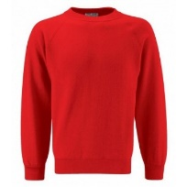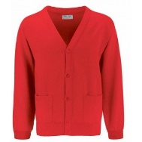 | 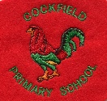  https://totstoteams.com/schools/cockfield-primary-school
Red sweatshirt, v-neck or cardigan without the school logo | 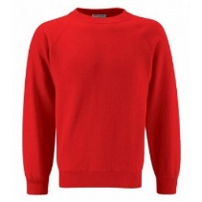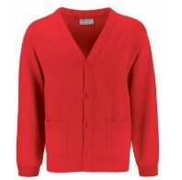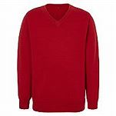 | Tesco  Sainsburys  Asda  Marks and Spencer  Matalan  Other high street clothes shops, e.g. H&M, Primark, Next etc…
Plain White Polo Shirt | 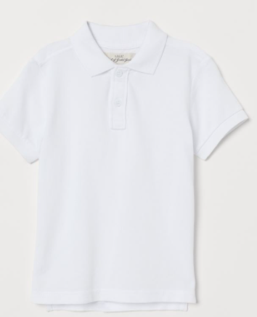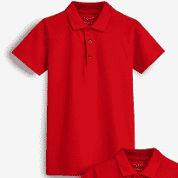
Plain grey or black, tracksuit bottoms or joggers | 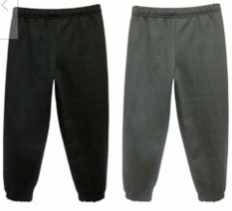
Plain grey or black leggings (long or cropped ¾ length) | 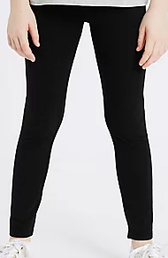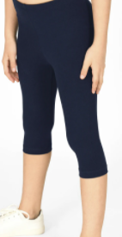
Plain grey, black or blue sports shorts or legging shorts | 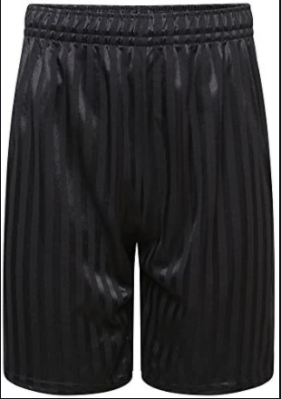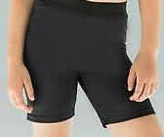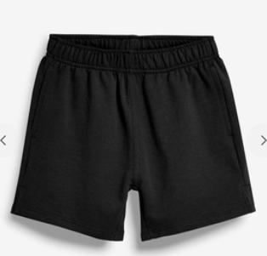
Plain black trainers or shoes | 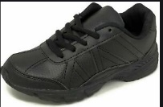  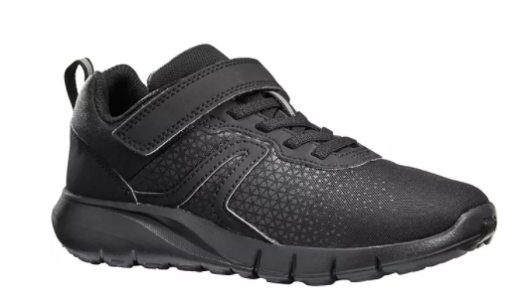 |  | Anywhere that sells children’s shoes/trainers

Skirts or pinafores can be worn with shorts underneath.

