Contact: | 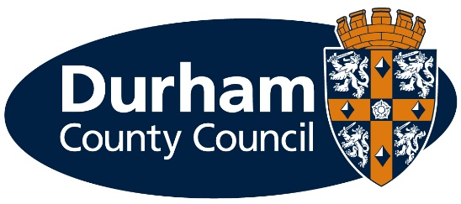  School Places and Admissions Team
Direct Tel: | 03000 265896
Fax: | 0191 3898150
e-mail: | schooladmissions@durham.gov.uk
Your ref:
Our ref: | CYPS/SPA/

6 September 2021
Application for a School Place – September 2022

Dear Parent/Carer

As you will be aware, your child is due to transfer to secondary school in September next year. The application process will open on 6 September 2021. You will need to read the Parent’s Guide “Primary and Secondary School Admission Guide in County Durham 2022/23”, as it contains essential information that will help you in making your child’s application. The guide is available on our website www.durham.gov.uk/schooladmissions

You must only complete one application and this must be to the Local Authority to which you pay your council tax (i.e. Home Local Authority).

If you live in County Durham, you need to complete an application to tell us which school you want your child to attend. You should list up to 3 school preferences and applying for just 1 school Does Not improve your chances of gaining a place at that school. You can apply for any school/academy in County Durham or in another Local Authority area.

Please apply on-line at www.durham.gov.uk/schooladmissions When you apply on-line you will receive an acknowledgement and you will be offered a school place for your child by email on 1 March 2022. Please save your log-in details as you will also be able to accept your child’s place on-line.

Please note that school places are allocated according to specific criteria which are different depending upon which school you apply for your child to attend. One criterion is “nearest school”. If you wish to know your nearest school, please contact us.

If your child’s offer of a school place is for an oversubscribed school (i.e. where there are more applications for a school than places available) we will offer your child a school place based on the child’s/parent’s address. We will request information on the child’s/parent’s address when we offer a school place, and the onus will be on you to prove your address if asked.

If you do not wish to apply on-line, you can download an application form from this website (or contact us and we will send you a paper application form) which must be received by us at the address below by the closing date. We strongly advise you to return the application form to us by "Royal Mail Signed for™" or “Royal Mail Special Delivery Guaranteed”. If you complete a paper application form you will receive a letter to inform you of the school place offered to your child.

Please note for both on-line applications and paper application forms, you will be required to read the disclaimer and sign/tick the box to agree that the information you provide on the application form is complete and correct otherwise the offer of a school place will be withdrawn.

The closing date for receipt of on-line/paper application forms is 31 October 2021.

Yours sincerely
School Places and Admissions Team.

