8.00 am – 8.55 am daily
£2.00 per session
£1.00 if you are receiving free school meals
No need to book just come along and join us in the main hall – please enter from the main yard
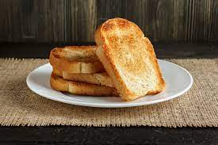
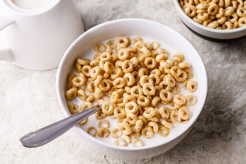
Cereals, squash, toast and fruit are available every day
Breakfast Club staff : Mrs Blackett

